STEP: CHOOSE TOPICS
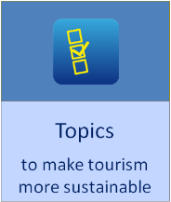 | Making tourism more sustainable is a multi-thematic, multi-stakeholder, global to local process. The DestiNet Topic Management Framework provides an integrated general contents list for covering all sustainable tourism thematics. It was developed in 2012 on the base of international frameworks (UNEP UNWTO) and European frameworks (EU) as part of the European FAST-LAIN project.
Deliverable: the HEI members of the NETWORK (WP1) will share the management of the TOPICS according to their competences and interests/priorities. in 2017 the 4 Triangle partner HEIs will start to share the management of the 8 TOPICS. New NETWORK HEIs will then take over topics, the management of the TOPICS then shall rotate.
Step 1: select your preferred topics to start with
- read the main TOPICS pages to get familiar with the challenges, objectives and roles of stakeholders
- select those main TOPICS which your HEI wants to manage in 2017. Please mark 2 or more.
- you may add keywords to specify your preferred topics.
>>>Enter your information below or send it as email to triangle@ecotrans.de
http://destinet.eu/topics  Main TOPICS:  Click to get familiar | Your preferred TOPICS:  enter your name | Here you can specify your choosen  topics with further keywords  e.g. sub-topics, landscape types, other
