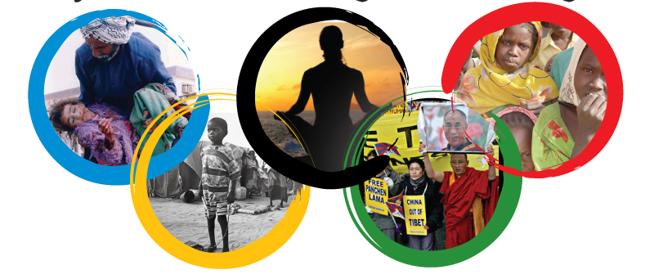
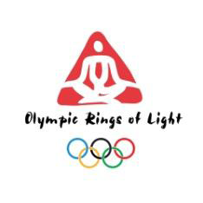

LONDON 2012 OLYMPIC PEACE CAMPAIGN

We can all take part in the London Olympic Games – making them a time of inner peace and global peace, as they were traditionally performed in ancient Greece.
LONDON 2012 OLYMPIC PEACE MAKER
Registration Form
Help to make the Olympic Peace really happen by working in a global coalition. What would that involve?
A London 2012 Olympic Peace Maker would use their professional and voluntary capacities to:
- Persuade governments to implement the truce
- Support the call for a One Minute Silence at the London Olympic Ceremony to mark the state of global peace
- Help to fundraise and provide logistical support to bring 40 teenagers living in conflict zones and areas of violence to the Olympic Opening Ceremony.
- Prepare and practice for personal inner peace during the 16 days of Olympic competition.
I wish to join in with the London 2012 Olympic Peace Campaign’s efforts to establish a coalition of people willing to make an Olympic Truce happen.
Name:
Position/Profession:
Address:
Postcode:
Country:
Email:
Cut and past this inform in to an email or return this form by email to gordon.destinet@ecotrans.de
Thank you. For further information see
http://destinet.eu/topics/sustainable-consumption-and-production/peace-through-tourism
http://www.facebook.com/pages/London-2012-Olympic-Peace-Campaign/211382448883873

