
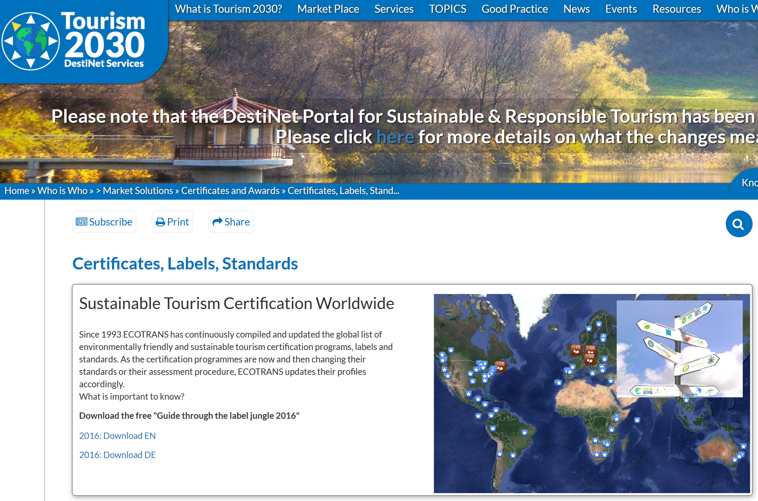
CSRTTC Examination System – Comprehension and Application of Tourism Sustainability Certification
Competence in Sustainable & Responsible Travel & Tourism Course TRIANGLE
Notes for Students & Tutors
The examination system for the CSRTTC course has been devised as an ‘assessment for learning’ process, with the aim of developing in successful participants the knowledge and skills involved in the certification of sustainable and responsible tourism development. This has been designed in accordance to ISEAL guidance on evaluation of auditor competence, from which the assessment process is given structure. (cf:Evaluation of Auditor Competence R074 Internal Version 1 - September, 2007 www.isealalliance.org)
Introduction to the exam
This section of the CSRTTC course examination method is to ensure you are fully informed of the Global Sustainable Tourism Council and its role in the current world of tourism sustainability certification, within the overall context of sustainable development vis a vis the SDG 2030 Goals. Success in this part of the examination aims to show you have the competence to accurately portray the GSTC accreditation process and can a) achieve their course examination standard, from which many of these questions are derived to preserve the integrity, and b) apply the Tourism 2030 Portal tool kit alongside your conceptual understanding of tourism sustainability certification.
Examination Questions 2018

Name of Examinee: Anna Kibireva
Email contact: katebelona@ gmail.com
Date of Assessment: 23/09/2019

Qu 1 Sustainable Development and Tourism Activity -Use your own words to describe the four key principles of sustainable development that should be followed in order to ensure the long-term sustainability of the tourism industry.
Principle 1 Using resources sustainably in order to satisfy not only your needs but also needs of future generations. Sustainable use of resources- natural, social and cultural – is crucial and makes long-term business sense.
Principle 2. Reducing over consumptioin and waste
Principle 3. Respect local culture and tradition, tourism has to benefit local community and encourage its development
Principle 4. Sustainable tourism is also based on the necessity of raising enviromental awareness of tourists, creating new type of tourists' and tourist business as well as governments' behaviour towards toursim assets and local communities.
Qu 2. List three publications/initiatives you could name as the important milestones in sustainable tourism certification since 1987?
A. Hamele, H. (1996). ”THE BOOK OF ENVIRONMENTAL SEALS & ECOLABELS” ENVIRONMENTAL AWARDS IN TOURISM An International Overview of Current Developments.
B. Honey, M., Rome, A. (2001). Protecting Paradise: Certification Programs for Sustainable Tourism and Ecotourism, Institute for Policy Studies, USA.
C. Sanabria, R., Skinner E. et al (2003). SUSTAINABLE TOURISM STEWARDSHIP COUNCIL RAISING THE STANDARDS AND BENEFITS OF SUSTAINABLE TOURISM AND ECOTOURISM CERTIFICATION. Coordinated by Rainforest Alliance.

Qu 3. What year was the GSTC formed?
1895
1967
2009 X
2015

Qu 4. Describe the main part of the GSTC’s mission? (Choose one)
a.To help all tourism organizations become accredited to the GSTC according to the GSTC criteria.
b. To encourage sustainability in all aspects of travel & tourism.
c. To develop an award for the most sustainable businesses
d. To promote sustainable travel and tourism to an international market-place.

Qu 5. Describe the four key areas of the GSTC’s objectives (choose one):
a. Certification–developing an international certificate for sustainable tourism businesses and destinations
.b.Accreditation – setting up an international organisation to develop and verify standards and practices applied by sustainable tourism certification programs.
c. Promoting greater market access for GSTC-accredited sustainable tourism certification programs.
d. Guiding destination management for better implementation of sustainable tourism development.
e. Requiring national tourism organisations to implement sustainable tourism policies marketing based on the GSTC Criteria.
Qu 6. Write down the GSTC’s four pillars of sustainability that structure the GSTC Criteria,
A Sustainable management
B Socio-economic impact
C Enviromental impact
D Cultural impact
Qu 8. Which organisation below is not a certification body? (Select one)
a. Biosphere Responsible Tourism
b. Travelife
c. Global Sustainable Tourism Council (GSTC)
d. TourCert
Qu 9. The GSTC currently offer a sustainable tourism standard the “GSTC-Recognized” status? Select one of criteria used for this purpose:
a. That the standard only works with sustainable products and service that have been assessed by the GSTC’s marketing group.
b. That the GSTC has verified that the standard aligns with the GSTC Criteria and is administered by an organisation that is a member of the GSTC.
c. That the standard has been reviewed by GSTC Accreditation Panel and deemed equivalent to the GSTC Criteria.
Qu 10 Which of the following is a correct statement regarding the “GSTC Certified” status? (Select one)
a. Certification bodies that have been awarded the GSTC-Approval for their standards can claim to be “GSTC Certified”.
b.Businesses (hotels, tour operators, attractions, destinations) certified by certifying bodies that are GSTC-Recognized or GSTC-Approved are designated as “GSTC Certified”.
c. Businesses (hotels, tour operators, attractions, destinations) certified by certifying bodies that are GSTC-Approved or GSTC-Accredited are designated as “GSTC Certified”.
d. Accreditation bodies that comply with the highest ISO or ISEAL social and environmental standards can use the “GSTC Certified” mark.
QU 11. Are the following statements about the GSTC Industry Criteria (“GSTC-Industry”) correct?
a. The GSTC-Industry can benefit all tourism entities, but some criteria may be justifiably not applicable to the specific local context. Is this True or False? True
b. GSTC-Industry should be used with the understanding that micro businesses may not achieve comprehensive application of all criteria. Is this True or False? True
Qu 12. Describe, in your own words, what a tourism business needs to consider in order to meet the GSTC sustainable tourism standard?
The level of their management sustainablity, social and economic impact as well as their cultural and enviromental impacts.

Qu 13. Is the following description of the term “conservation management” as used in the GSTC Industry Criteria - ie- ‘A planned intervention in order to maintain a species or habitat in a favourable condition’. -True
Qu 14. A destination can achieve the “GSTC Certified” mark by: (Select one)
a. Creating a national sustainable tourism standard that meets the “GSTC Recognized” requirements.
b. Becoming certified by a certifying body that has achieved the “GSTC Recognized” status.
c. Becoming certified by a certifying body that has achieved the “GSTC Approved” or “GSTC Accredited” status.
d. Becoming certified by the GSTC’s marketing group.
Qu 15. Which of the following are key aspects of a sustainable destination management strategy?
Mark as either T/F
a. A destination needs to develop a tourism strategy appropriate to its scale. True
b. Destination management organizations (DMOs) do not need to develop a sustainability strategy unless it is required by law. False
c.The GSTC require that a sustainable destination management strategy must be published and reviewed periodically. True
d. The development of a destination’s sustainability strategy requires permission of the regional government. False
e. The destination sustainability management strategy must cover environmental, social, cultural and economic issues. True
.
Qu 16. Could you see how to use the GSTC Criteria in practical terms in an organisation or place you know? List three ways in which you can now apply the GSTC Industry Criteria and/or the Destination Criteria in your own work.
Estrela Da Luz Hotel Portugal - I would like to apply the following criteria: D1.3 Energy conservation by type and steps are taken to minimize overall consumption. (a. Total energy used is monitored and managed. b. Energy used per tourist/night for each type of energy is monitored and managed. c. Renewable sources are favoured and the share of renewable energy in total energy supply is monitored and managed. d. Equipment and practices are used that minimize energy use. e. Goals for reducing energy consumption are in place. f. Staff and guests are given guidance on minimizing energy use.); D1.4 Water conservation (Water risk has been assessed and documented. b. Where water risk has been assessed as high, water stewardship goals have been determined. c. Water used per tourist/night per source is monitored and managed. d. Equipment and practices are used that minimize water consumption. e. Water originates from a legal and sustainable source which has not previously affected, and is unlikely in future to affect, environmental flows. f. Consideration is given to cumulative impacts of tourism in the locality on water sources. g. Goals for reducing water consumption are in place. h. Staff and guests are given guidance on minimizing water use; D2.4 Solid waste, including food waste, is measured, mechanisms are in place to reduce waste and, where reduction is not feasible, to reuse or recycle it. Any residual waste disposal has no adverse effect on the local population or the environment.
List three certificates that have received ‘GSTC – Recognized’status.

A European Ecotourism Labelling Standard (EETLS)
B TourCert
C Green Globe

List three tourism sustainability certificates with more than one hundred businesses in Europe.
A European Charter
B Green Key
C Green Tourism

Please state in your own words the benefits of certification for

A a business such as ah hotel or tour operator
Being certified by a GSTC-Accredited Certification Body (CB) means that tour operator complies with the highest social and environmental standards on the market. As public concern grows about the harmful effects and the positive impacts of travel and tourism, certification provides a credible solution to complex environmental and social issues. Travel providers proudly display information regarding their certificate and the certifying body that issued it. Doing so informs your stakeholders — from customers to ownership and to your supply chain — that your business is operated with sound management that looks to the future and not merely at today. Increasingly, luxury travelers as well as regular travelers, and your fellow travel provider clients are seeking confirmation that sustainability practices are in place. Also increasingly, travel companies are looking for a product that is not only certified sustainable, but certified sustainable by a certification program that is GSTC Accredited. Tour operator will strenghen its position in market place, get new clients and also save money using waste, energy and water saving technologies.

B a destination
Being a Certified Destination means that your destination complies with the highest social and environmental standards on the market. As public concern grows about the harmful effects and the positive impacts of travel and tourism, Certification provides you a credible solution to complex environmental and social issues. You can establish stable development for the future, save resources, strengthen local traditions and culture, sometimes if its relevant to your destination-to reduce poverty- as well as support economic growth of your area and prevent tourists bringing any harm to local environment. You can also support local economy and businesses and raise tourists interests.
You also can prevent any harmful environmental impacts and preserve a wildlife and biodiversity.

C from the traveler’s point of view
Travelers can affect change by asking hotels and other travel providers to gain certification as the most effective means to provide strong evidence that their operations are sustainable. |choosing certified destinations and businesses can save your time for searching appropriate products and decide which one to choose, it can also increase your self-feeling of doing good things to the planet, help to educate your kids if you travel with them, and it can also help you to get much richer and ore authentic experience by for example visiting a certified destination because you will know that for example local culture and traditions that you are offered to discover are authentic and really belong to this community and were not just created to attracting tourists. You can also get to know better such part of local life as local food for example by choosing a certified accommodation provider that is obliged to buy fresh products from local farmers. You can also get much more informational support about the destination as certified hotels are obliged to provide you information about our certified products ( for example you will get information about Blue Flag beaches). Finally, choosing certified products and services is good for your health.

Thank you for completing this examination. Now please upload your completed submission to your CSRTTC Course folder, and inform your tutor by email or Skype that you have completed all your modules, including this comprehension assessment.

